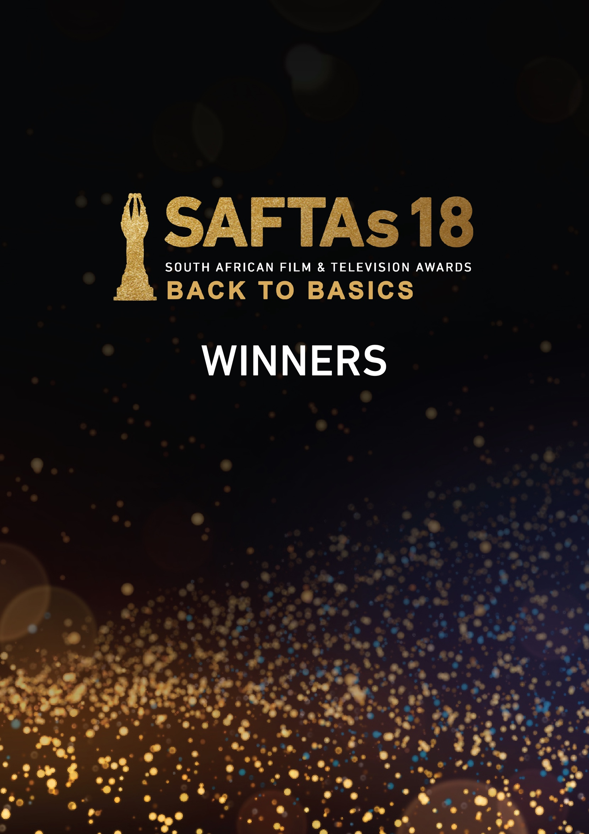

**BEST ACHIEVEMENT IN SOUND - DOCUMENTARY**

**!Aitsa**

Practitioner: Simon Kohler

Production House: MED CINE

**BEST ACHIEVEMENT IN EDITING - DOCUMENTARY**

**Rise: The Siya Kolisi Story**

Practitioner: Ebenhaezer Smal (Haezer)

Production Orange Films and Star Films

**BEST ACHIEVEMENT IN CINEMATOGRAPHY - DOCUMENTARY**

**Rosemary's Hitlist**

Practitioner: Sims Phakisi

Production House: Idea Candy

**BEST ACHIEVEMENT IN DIRECTING - DOCUMENTARY**

**Music Is My Life - Joseph Shabalala and Ladysmith Black Mambazo**

Practitioner: Mpumi "Supa" Mbele

Production House: Free Women Films & Nine To Five Creative Agency

**BEST DOCUMENTARY SHORT**

**Faces of Fortune**

Production House: Red Coat Films

**BEST MADE FOR TV DOCUMENTARY OR DOCUMENTARY SERIES**

**Pale Ya Kosa**

Production House: Full Circle Productions

**BEST DOCUMENTARY FEATURE**

**!Aitsa**

Production House: MED CINE

**BEST CHILDREN’S PROGRAMME**

**Baking With the Rey's**

Production House: Rey Productions

**BEST EDUCATIONAL PROGRAMME**

**The Khoekhoe Saga**

Production House: On Set Images

**BEST FACTUAL PROGRAMME**

**Outopsie**

Production House: 7EVENTY9 Films

**BEST COMPETITION REALITY SHOW**

**Kokkedoor: Vuur & Vlam**

Production House: Homebrew Films

**BEST STRUCTURED SOAPIE REALITY SHOW**

**Young, Famous and African S2**

Production House: Urban Brew Studios & A Pop Media

**BEST** **STRUCTURED OR DOCU-REALITY SHOW**

**Reno Race**

Production House: RHT United T/A RichCon

**BEST YOUTH PROGRAMME**

**MTV Shuga Down South - Season 3**

Production House: Burnt Onion Productions

**BEST ONLINE CONTENT**

**The Adventures of Noko Mashaba - Struggles of SA Youth**

Production House: Rams Comics

**BEST LIFESTYLE PROGRAMME**

**Die Argitekte (The Architects)**

Production House: Thank you kindly, Bobby

**BEST CURRENT AFFAIRS PROGRAMME**

**Checkpoint**

Production House: eNCA

**BEST MADE FOR TV MOVIE**

**'n Tyd van Waterpere**

Production House: Sonvelt Media

**BEST INTERNATIONAL FORMAT**

**The Masked Singer Season 1**

Production House: Rose and Oaks Media

**BEST ENTERTAINMENT PROGRAMME**

**Koppestamp**

Production House: Just Ad Production

**BEST VARIETY SHOW**

**Sport@10**

Production House: SABC

**BEST ACHIEVEMENT IN MAKE-UP AND HAIRSTYLING - TV COMEDY**

**Roomies**

Practitioner: Yonela Nombewu

Production House: 32Done Productions

**BEST ACHIEVEMENT IN WARDROBE - TV COMEDY**

**Roomies**

Practitioner: Thembelihle Buthelezi

Production House: 32Done Productions

**BEST ACHIEVEMENT IN SOUND - TV COMEDY**

**Yoh! Christmas**

Practitioners: Themba Mashinini & Guy Steer

Production House: BBZEE Films

**BEST ACHIEVEMENT IN ART DIRECTION - TV COMEDY**

**Magaeng**

Practitioner: Kagiso Malefane

Production House: Burnt Onion Productions

**BEST ACHIEVEMENT IN EDITING - TV COMEDY**

**Yoh! Christmas**

Practitioners: Tessa Verfuss, Quinn Lubbe & Miriam Arndt

Production House: BBZEE Films

**BEST ACHIEVEMENT IN SCRIPTWRITING - TV COMEDY**

**Yoh! Christmas**

Practitioners: Tiffany Barbuzano, Zoleka Monare, Johny Barbuzano & Gillian Breslin

Production House: BBZEE Films

**BEST ACHIEVEMENT IN CINEMATOGRAPHY -TV COMEDY**

**Yoh! Christmas**

Practitioner: James Adey

Production House: BBZEE Films

**BEST ACHIEVEMENT IN DIRECTING - TV COMEDY**

**Yoh! Christmas**

Practitioners: Johnny Barbuzano, Lauren Chengan, Sanele Zulu, Zolani Phakade &

Chris Beasley

Production House: BBZEE Films

**BEST ACHIEVEMENT IN MAKE-UP AND HAIRSTYLING - TV DRAMA**

**Shaka Ilembe**

Practitioner: Queen Motlatle

Production House: The Bomb Shelter Film Company

**BEST ACHIEVEMENT IN WARDROBE - TV DRAMA**

**Shaka Ilembe**

Practitioner: Shirley Masondo

Production House: The Bomb Shelter Film Company

**BEST ACHIEVEMENT IN ART DIRECTION - TV DRAMA**

**Shaka Ilembe**

Practitioners: Dylan Lloyd & Nokuthula Sishi

Production House: The Bomb Shelter Film Company

**BEST ACHIEVEMENT IN SPECIAL EFFECTS (SFX) IN HAIR AND MAKE-UP FILM/TV**

**Do Your Worst**

Practitioners: Nicola Roodt, Ronwyn Jarrett & Cassidy Lombard

Production House: Blingola Media

**BEST ACHIEVEMENT IN SOUND - TV DRAMA**

**Shaka Ilembe**

Practitioners: Athanasios Koundouris, Vaughan Phillips, Beyond Sound & On- Key Sound

Production House: The Bomb Shelter Film Company

**BEST ACHIEVEMENT IN ORIGINAL MUSIC/SCORE - TV DRAMA**

**Shaka Ilembe**

Practitioner: Philip Miller

Production House: The Bomb Shelter Film Company

**BEST ACHIEVEMENT IN AN ORIGINAL SONG – TV DRAMA**

**Classified**

Practitioner: Zethu Mashika

Production House: Diprente

**BEST ACHIEVEMENT IN EDITING - TV DRAMA**

**Shaka Ilembe**

Practitioners: Sibongeleni Mabuyakhulu, Llewellyn Rice & Megan Gill

Production House: The Bomb Shelter Film Company

**BEST ACHIEVEMENT IN VISUAL EFFECTS(VFX) – FILM/TV**

**Shaka Ilembe**

Practitioner: LUMA Animation

Production House: The Bomb Shelter Film Company

**BEST ACHIEVEMENT IN CINEMATOGRAPHY - TV DRAMA**

**Shaka Ilembe**

Practitioner: Zeno Petersen

Production House: The Bomb Shelter Film Company

**BEST ACHIEVEMENT IN SCRIPTWRITING - TV DRAMA**

**Shaka Ilembe**

Practitioners: Thishiwe Ziqubu, Paul Grootboom, Catherine Stewart, Andrew Peterson, Daniel Zimbler, Angus Gibson, Desiree Markgraaff, Nhlanhla Mtaka, Jacob Ntshangase, Steven Pillemar, Hlonipha Mokoena & Benedict Carton.

Production House: The Bomb Shelter Film Company

**BEST ACHIEVEMENT IN DIRECTING - TV DRAMA**

**Shaka Ilembe**

Practitioners: Angus Gibson, Zeno Petersen, Adze Ugah, Mnqondisi Ngubane & Catherine Stewart

Production House: The Bomb Shelter Film Company

**BEST ACHIEVEMENT IN MAKE-UP AND HAIRSTYLING - TV SOAP/TELENOVELA**

**1802-Love Defies Time**

Practitioners: Silindile Dladla & Refiloe Maphunya

Production House: Hela Media

**BEST ACHIEVEMENT IN WARDROBE - TV SOAP/TELENOVELA**

**House of Zwide**

Practitioners: Bevely Mogorosi & Teddy Geldart

Production House: The Bomb Shelter Film Company

**BEST ACHIEVEMENT IN EDITING –TELENOVELA**

**Outlaws**

Practitioners: Natalie Varoy, Ebenhaezer Smal, Bongi Malefo, Siwelile Mbanjwa & Nandi Mehlomakulu

Production House: Tshedza Pictures

**BEST ACHIEVEMENT IN ORIGINAL MUSIC/SCORE – TELENOVELA**

**Outlaws**

Practitioner: Brendan Jury

Production House: Tshedza Pictures

**BEST ACHIEVEMENT IN AN** **ORIGINAL SONG – TELENOVELA**

**The River**

Practitioners: Brendan Jury & Sindi Dlathu

Production House: Tshedza Pictures

**BEST ACHIEVEMENT IN CINEMATOGRAPHY – TELENOVELA**

**Outlaws**

Practitioner: Ntobeko Dlamini

Production House: Tshedza Pictures

**BEST ACHIEVEMENT IN SOUND – TV SOAP**

**Binnelanders**

Practitioners: Eric McKechnie & Barry Gillot

Production House: Stark Films

**BEST ACHIEVEMENT IN SOUND –TELENOVELA**

**Outlaws**

Practitioners: Geoff Kock & Clark Fivaz

Production House: Tshedza Pictures

**BEST ACHIEVEMENT IN ART DIRECTION - TV SOAP/TELENOVELA**

**Outlaws**

Practitioner: Waldemar Coetsee

Production House: Tshedza Pictures

**BEST ACHIEVEMENT IN SCRIPTWRITING – TELENOVELA**

**Outlaws**

Practitioners: Gwydion Beynon & Phathutshedzo Makwarela

Production House: Tshedza Pictures

**BEST ACHIEVEMENT IN DIRECTING - TELENOVELA**

**Outlaws**

Practitioners: Tebogo Malope, Thembalethu Mfebe, Nthabi Tau & Menga Nhlabathi

Production House: Tshedza Pictures

**BEST ACHIEVEMENT IN SCRIPTWRITING – TV SOAP**

**Skeem Saam**

Practitioners: Khomotjo Aphane, Myrah Molokomme, Metsa Makhwidiri, Joseph Senosi, Kelton Sinyosi, Sibusisiwe Manqele, Siphamandla Madondo & Zola Hlungwani

Production House: Peu

**BEST ACHIEVEMENT IN DIRECTING – TV SOAP**

**Skeem Saam**

Practitioners: Mmoni Moabi, Percy Maboane, Ricardo Klassen & Kgomotso Lebakeng

Production House: Peu

**BEST ACHIEVEMENT IN MAKE-UP AND HAIRSTYLING - FEATURE FILM**

**iNumber Number: Jozi Gold**

Practitioner: Theola Booyens

Production House: Quizzical Pictures

**BEST ACHIEVEMENT IN COSTUME DESIGN – FEATURE FILM**

**Hans Steek die Rubicon Oor**

Practitioner: Marné van der Burgh

Production House: Red Letter Day Pictures

**BEST ACHIEVEMENT IN PRODUCTION DESIGN – FEATURE FILM**

**iNumber Number: Jozi Gold**

Practitioner: Bathoni Robinson

Production House: Quizzical Pictures

**BEST ACHIEVEMENT IN SOUND DESIGN - FEATURE FILM**

**BLINDELINGS**

Practitioner: Tim Pringle

Production House: 17 FILMS

**BEST ACHIEVEMENT IN EDITING – FEATURE FILM**

**Runs in the Family**

Practitioner: Eva Du Preez

Production House: Giant Films

**BEST ACHIEVEMENT IN ORIGINAL MUSIC/ SCORE - FEATURE FILM**

**Big Nunu's Little Heist**

Practitioner: Joel Assaizky

Production House: DIPRENTE

**BEST ACHIEVEMENT IN AN ORIGINAL SONG - FEATURE FILM**

**iNumber Number: Jozi Gold**

Practitioners: Israel Matseke Zulu,Selby Ngozo, and Moses Sibeko

Production House: Quizzical Pictures

**BEST ACHIEVEMENT IN CINEMATOGRAPHY – FEATURE FILM**

**iNumber Number: Jozi Gold**

Practitioner: Tom Marais

Production House: Quizzical Pictures

**BEST ACHIEVEMENT IN SCRIPTWRITING - FEATURE FILM**

**The Fragile King**

Practitioner: Tristan Holmes

Production House: The Ergo Company & Star Films

**BEST STUDENT FILM - Animation**

**By Two**

Institution: The Animation School

**BEST STUDENT FILM - Live Action**

**Anguish**

Institution: AFDA

**BEST ANIMATION**

**Kizazi Moto Generation Fire: Herderboy**

Production House: Triggerfish Animation Studios

**BEST SUPPORTING ACTRESS IN A TV SOAP**

**Marlee van der Merwe (Binnelanders)**

Production House: Stark Films

**BEST SUPPORTING ACTOR IN A TV SOAP**

**Kabelo Thai (Scandal!)**

Production House: Ochre Media

**BEST SUPPORTING ACTRESS IN A TELENOVELA**

**Mmarona Motsegoa (Redemption)**

Production House: Burnt Onion Productions & Seriti Films

**BEST SUPPORTING ACTOR IN A TELENOVELA**

**Mpho Sebeng (The Estate)**

Production House: Clive Morris Productions

**BEST ACTRESS IN A TV SOAP**

**Elizabeth Serunye (Skeem Saam)**

Production House: Peu

**BEST ACTOR IN A TV SOAP**

**Germandt Geldenhuys (Binnelanders)**

Production House: Stark Films

**BEST ACTRESS IN A TELENOVELA**

**Zikhona Sodlaka (Gqeberha - The Empire Season 1)**

Production House: Tshedza Pictures

**BEST ACTOR IN A TELENOVELA**

**Presley Chweneyagae (The River)**

Production House: Tshedza Pictures

**BEST TV SOAP**

**Skeem Saam**

Production House: Peu

**BEST TELENOVELA**

**Outlaws**

Production House: Tshedza Pictures

**BEST SUPPORTING ACTRESS IN A TV DRAMA**

**Natasha Sutherland (Lioness Season 2)**

Production House: Ochre Media ADO Arena Holdings

**BEST SUPPORTING ACTOR IN A TV DRAMA**

**Nat Ramabulana (Fatal Seduction)**

Production House: Ochre Media ADO Arena Holdings

**BEST ACTRESS IN A TV DRAMA**

**Shannon Esra (Lioness Season 2)**

Production House: Ochre Media ADO Arena Holdings

**BEST ACTOR IN A TV DRAMA**

**Thembinkosi Mthembu (Shaka iLembe)**

Production House: The Bomb Shelter Film Company

**BEST TV DRAMA**

**Shaka iLembe**

Production House: The Bomb Shelter Film Company

**BEST SUPPORTING ACTRESS IN A TV COMEDY**

**Dorothy Anne Gould** **(Yoh! Christmas)**

Production House: BBZEE Films

**BEST SUPPORTING ACTOR IN A TV COMEDY**

**Kagiso Modupe (Yoh! Christmas)**

Production House: BBZEE Films

**BEST ACTRESS IN A TV COMEDY**

**Marion Holm (Taktiek)**

Production House: Nagvlug Films

**BEST ACTOR IN A TV COMEDY**

**Prev Reddy (Miseducation)**

Production House: Burnt Onion Productions

**BEST TV COMEDY**

**Yoh! Christmas**

Production House: BBZEE Films

**BEST SHORT FILM**

**Father's Day**

Production House: Bunzi Bear Pictures & The Ergo Company

**BEST SUPPORTING ACTRESS IN A FEATURE FILM**

**Jennifer Steyn** **(The Fragile King)**

Production House: The Ergo Company & Star Films

**BEST SUPPORTING ACTOR IN A FEATURE FILM**

**Adrian Alper** **(Seconds)**

Production House: Free Women Films & Full Circle Productions

**BEST ACTRESS IN A FEATURE FILM**

**Antoinette Louw (The Fragile King)**

Production House: The Ergo Company & Star Films

**BEST ACTOR IN A FEATURE FILM**

**Vusi Kunene** **(Seconds)**

Production House: Free Women Films & Full Circle Productions

**BEST ACHIEVEMENT IN DIRECTING – FEATURE FILM**

**The Fragile King**

Practitioner: Tristan Holmes

Production House: The Ergo Company & Star Films

**BEST FEATURE FILM**

**The Fragile King**

Production House: The Ergo Company & Star Films

**BEST NATURAL HISTORY AND ENVIRONMENTAL PROGRAMME**

**Legends of Venom: Viper**

Production House: Earth Touch

**BEST TV PRESENTER (PUBLIC VOTE)**

* **Laconco** **(Forever Thina S1)**

Production House: Urban Brew Studios

**MOST POPULAR TV SOAP OR TELENOVELA (PUBLIC VOTE)**

* **Scandal!**

Production House: Ochre Media

**SAFTAs18 DISCRECTIONARY AWARDS**

**Lifetime Achiever Award**

* Arthur Molepo
* Mfundi Vundla

**Youth Achiever Award**

* Kenneth Vuyani Mbalula

**Outstanding Person with Disability Contributor Award**

* Tebatso Mashishi

**Outstanding Provincial Contributor Award**

* Sizwe Shabangu

**Emerging Filmmaker Award**

* Josh Crickmay

**Follow our social media platforms:**

SAFTAs: X /Twitter: @saftas1, Facebook & Instagram: @saftassa, TikTok: @saftas_sa