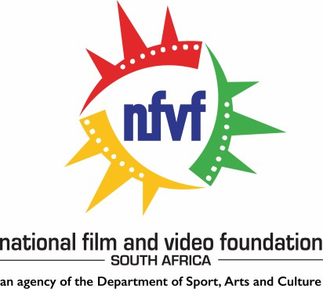

ERRATUM NOTICE
All enquiries relating to this RFT may be addressed to nfvftenders@nfvf.co.za
- The RFT closing date is extended from 04 February 2026 to 13 February 2026.

NFVF would like to inform prospective bidders of the following:
The National Film and Video Foundation (NFVF) hereby issue an erratum for the RFT advertised on NFVF website on 15 January 2026. The RFT number is RFT 11 2025–2026 for appointment of a service provider for provide external information technology support services to NFVF for a period of 36 months.
RFT 11 2025-2026
APPOINTMENT OF A SERVICE PROVIDER TO PROVIDE EXTERNAL INFORMATION
TECHNOLOGY SUPPORT SERVICES TO NFVF FOR A PERIOD OF 36 MONTHS

87 Central Street, Houghton, 2198, South Africa Private Bag X04, Northlands, 2116, South Africa
Tel: +27 11 483 0880 Fax: +27 11 483 0881 Email: info@nfvf.co.za Website: www.nfvf.co.za

Councillors:
Mr. Leon van Nierop (Chairperson); Mr. Mthokozisi Radebe (Deputy Chairperson); Ms. Andrea Gordon; Mr. Simon Clarke;
Ms. Omphemetse Mokgosi; Mr. Tony Ferreira; Ms. Siphosethu Mtamzeli; Mr. Chad Louw;
Ms. Nondumiso Madlala; Ms. Nobuntu Dubazana; Mr. Yazeed Kamaldien;
Acting Chief Executive Officer: Ms. Onke Dumeko

